1. <http://www.esa.int/Our_Activities/Space_Science/Asteroids_Structure_and_composition_of_asteroids>
   1. Metals
   2. Carbon
   3. Silicon
2. <http://www.uapress.arizona.edu/onlinebks/ResourcesNearEarthSpace/resources19.pdf>
3. <https://arxiv.org/ftp/arxiv/papers/1502/1502.05008.pdf>
   1. Primitive meteorites and non-chondritic meteorites – May contain Olivine
      1. Vitreous color
      2. Olive-green color
      3. May alter to reddish-brown color due to oxidation of iron
      4. 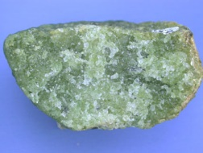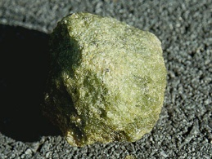 Green Unoxidized Color
      5. 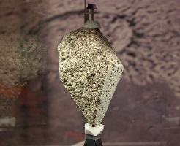 Lunar olivine basalt sample
      6. 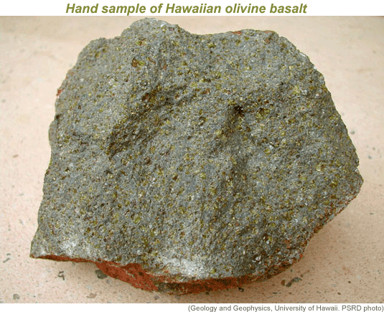 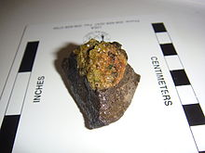 Reddish Oxidized Color
   2. Primitive meteorites and non-chondritic meteorites – May contain Pyroxene
4. <https://en.wikipedia.org/wiki/Murchison_meteorite>
   1. Amino acids found on asteroids include glycine, alanine and glutamic acid as well as unusual ones like isovaline and pseudoleucine.
   2. Alkanes were also found
   3. A family of amino acids like Diamino acids were found
      1. Asparagine, glutamine, lysine, ornithine, and 2,6-diaminopimelic acid
5. <https://en.wikipedia.org/wiki/Asteroid_mining>
   1. Metals include gold, iridium, silver, osmium, palladium, platinum, rhenium, rhodium, ruthenium, tungsten, iron, cobalt, manganese, molybdenum, nickel, aluminium, and titanium.